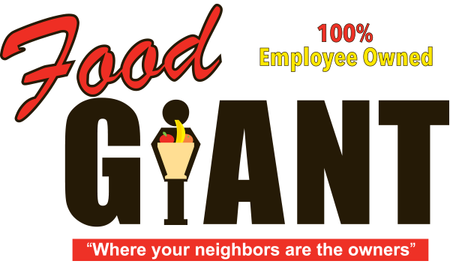

**COT 6931 Progress Report 2**



Food Giant Sales Flyer Generator

**Student - Kendrick Hagerman**

**Client - John Webb**

**Date: 3/26/2017**

**Dates Covered: 2/26/2017 - 3/26/2017**

Table of Contents

Project Background: 2

Terms of Reference & Key Objectives 2

Terms of Reference 2

Key Objectives (from SRS) 3

SRS001 3

SRS002 3

SRS003 3

SRS004 3

Discussion of achievements since last reporting 3

Discussion of problems that have arisen 3

Discussion of work that lies ahead 4

Assessment of whether you are on target 4

Risk Assessment Update 4

Update Time Schedule 4

# Project Background:

The project came about during a discussion with a high-school friend of mine, John Webb. I was looking for a project to work on and he presented this idea.

Six division managers at Food Giant (a grocery chain) want a program for their store managers that will help them quickly create sale flyers based on items these store managers select. Food Giant already has global sale flyers but these are made and shipped from corporate. The division managers want the store managers to be able to quickly print custom flyers for perishable items they have excess stock in to help sell these items before they expire. This will help them to sell excess stock at a store and increase revenue.

Prior to me accepting the project, the managers met with a 3rd party development team in order to get the program created, but the team’s budget was too high, and the project was never started.

The eventual outcome of this project is to allow store managers to have more control over their items’ sale price so they can sell items at a lower price before they have to throw away the expired inventory. Eventually, this program could potentially replace how they create flyers (they manually create flyers by using a simple design program) to allow the company to have higher quality flyers like larger grocery chains, like Publix.

# Terms of Reference & Key Objectives

## Terms of Reference

|  |  |
| --- | --- |
| Term | Definition |
| ASP.NET | Active Server Pages |
| GUI | Graphical User Interface |
| MVVM | Model View View-Model |
| QA | Quality Assurance |
| SDD | Software Design Description |
| SPMP | Software Project Management Plan |
| SQL | Structured Query Language |
| SRS | Software Requirements Specifications |
| STD | Software Test Document |

## Key Objectives (from SRS)

Please see Hagerman_Kendrick_Software_Requirements_Specification.docx for details and sub requirements for SRS items.

### SRS001

Implement a program as a GUI that allows a store manager to select from one or more template types and categorized items created from a database.

### SRS002

Create a SQL database used to store Food Giant data.

### SRS003

Deploy this program onto a server that the store managers, division managers and division manager’s assistants can log in to in order to print a flyer, add a new product and associated images, or add a new flyer template.

### SRS004

Create a User Guide for the Food Giant Flyer program

# Discussion of achievements since last reporting

Since we had Spring Break and I achieved major goals in the first report, I have less to discuss than the first progress report. Here is a list of achieved objectives:

* Continued to discuss requirements with client multiple times and compiled these requirements in SRD
* Heavily refined design documents. Feeling more confident that final design documents will be complete in April.
* Simplified and solved design problems I ran into during requirements and prototype development (issue explained below)
* Mostly completed final program layout
* Refined prototype of UI with MVVM layout. This was to figure out how I would design certain sections of the program
* Continuing to use Source Control Git repository on Github, allowing me to have source control on project and documentation.

# Discussion of problems that have arisen

* New major design issue that appeared during prototype research: ASP.NET requires significant overhead to use in project. A brief summary of the issue is as follows: Web Applications require many complex pieces and there is no way to simply open an ASPX file using parameters without creating the entire Web/Server model, which is more complex than the project should be, which negatively impacts design, implementation and maintainability. Essentially, there is no way to “pick and choose” what sections I needed. Updating ASPX files is more complex than expected as well. The solution was to figure out a way to generate all Flyer Templates in different C# files, removing ASP.NET from the project and reducing the complexity of the program while still fulfilling all SRS requirements.
* Issue with getting prototype application to work with database. Investigated error and lead to finding out about database connection issues. This lead to me refining my database connection section of my design document to be more specific about what SQL Database I will use and what connection logic I will use in the Database Interface program.
* Difficult to get face-to-face meetings with stakeholders due to school and work. Main stakeholder (John) lives over an hour away and works 6 days a week, usually on weekends.
* Difficulty in communicating technical requirements to stakeholder. I’m still not sure how they want this program deployed, only that they do.
* Budget concerns – though I am working for free due to school, the stakeholder will still need to spend money to host the program and database for their customers, and I do not know what their budget is for that.
* Other stakeholders – I have not talked to other 5 division managers and do not know their goal. I am presenting my prototype to all of them in April, which could quickly turn chaotic if they have disagreeing ideas. Logged as risk.

# Discussion of work that lies ahead

* Polish new C# Flyer Prototype layout before April meeting
* Finish design documents on programs
* Start and Complete actual program implementation (in Fall)
* Host program on a server-side system (Microsoft Azure) and test
* Complete test cases
* Complete all other minimum project artifacts - (SPMP, SRS, User’s Manual, QA plan, test cases, etc.)

# Assessment of whether you are on target

* Design work is going well, but I am not certain I can meet prototype demonstration date. I will discuss issue with Stakeholder and see if I can get a few more weeks of input from him before taking it in for demo.
* To sum up, I feel confident I can have a final program that Food Giant can use by August, but am unsure about prototype date.

# Risk Assessment Update

Please see the attached Hagerman_Kendrick_Risk_Mitigation and Hagerman_Kendrick_Risk_Matrices files

# Update Time Schedule

Please see the attached Hagerman_Kendrick_Schedule